# PERSONAL PROFILE ACADEMIC STUDIES

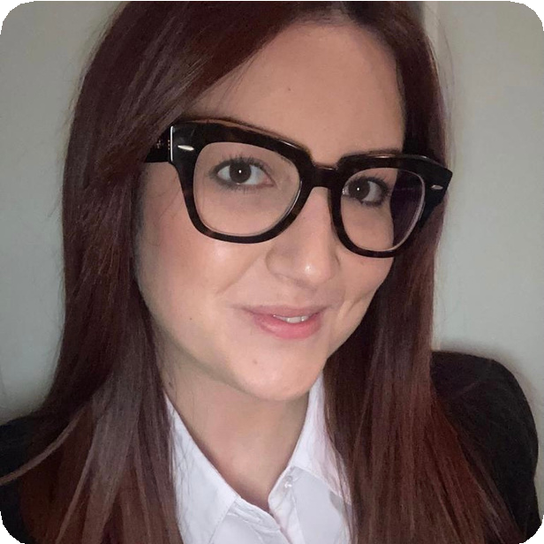

MARIA TERESA CAPODIVENTO



Strong passion for foreign languages and cultures. increasing interest in the Chinese market.

Eager to embrace change and to learn through work experience.

Key points: determination and attention to details.

CONTACTS

Via Salvatore Quasimodo 1, Trinitapoli (BT), Italia.

 [mari050998@gmal.com](mailto:mari050998@gmal.com) +39 3381381972

Maria Teresa Capodivento

LEVEL-1 MASTER COURSE 2020 - 2021

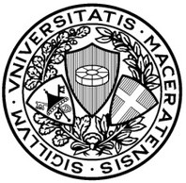

Università degli Studi di MACERATA Global management for China- GMC Expected graduation date: 09/2021

BACHELOR'S DEGREE 2017 - 2020

Final degree mark: 109/110 Graduation date: 27/10/2020 Università degli Studi di MACERATA

Specific field of the degree course: Language Translation and Interpreting L-12 - 1st level degree in Applied languages.

HIGH SCHOOL DIPLOMA IN LANGUAGES MARGHERITA DI SAVOIA

2017

Languages High School

Liceo Scientifico Statale Aldo Moro , MARGHERITA DI SAVOIA (BT) School-leaving examination mark: 100/100 cum laude

Secondary school diploma: Italian secondary school diploma Secondary school attended: Public school

# WORK EXPERIENCES

* Project Manager Assistant

CHIC INVESTMENT GROUP

MILANO (MI)

05/2021 ‐ 08/2021

Employed as: Intern/trainee |

Company sector: Business Consultancy,

Chinese Market

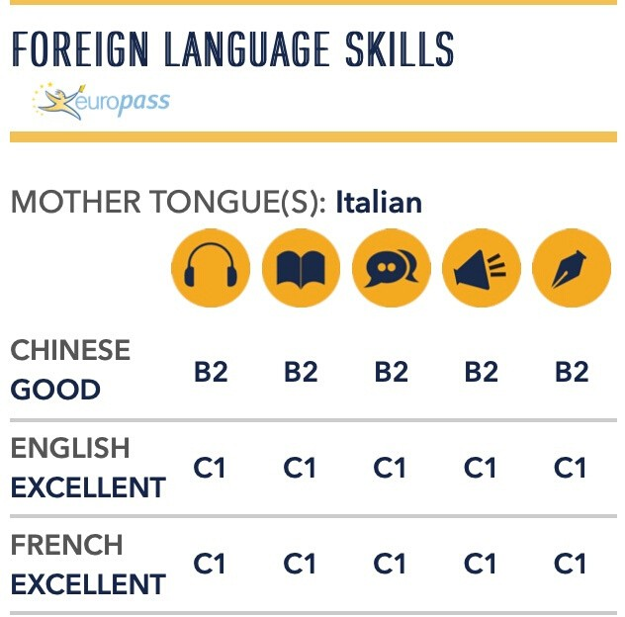Receptionist

Commerce, hotels, public activities (chemists shop included) TERME DI MARGHERITA DI SAVOIA S.R.L. MARGHERITA DI SAVOIA (BT)

07/2020 - 09/2020

Employed as: intern/trainee - fixed-length contract | Company sector: Customer service.

# Booth Assistant

FICO EATALY WORLD (BO) 06/2019 - 06/2019

Volunteer activities

# Library assistant

LILITH MED 2000 TRINITAPOLI (BT) 09/2018 - 09/2018. Employed as: apprentice - fixed-length contract



DIPLOMAS AND CERTIFICATES

**EXTRA COURSES**

OFFICE AUTOMATION

SYSTEMS AND NETWORKS MANAGEMENT

DATA MANAGEMENT GRAPHICS AND

MULTIMEDIA

ICT CERTIFICATES



CHINA 2019

FOREIGN LANGUAGE SKILLS

Chinese HSK 4 Hanyu Shuiping Kaoshi, Hanban Confucius Institute,08/02/2020, Europass level B2

Chinese HSKK Speaking(Preliminary)examination, Hanban Confucius Institute, 31/05/2020, Europass level B1

English CAE,University of Cambridge,01/01/2020, Europass level C1

French DALF Alliance Francaise, Bari, March 2021,European level C1

Intensive French course, Alliance Française of Bari- Advanced French -C1 : 40h 01/12/2020-04/02/2021

Intensive Chinese course, Confucius Institute of Macerata- Intermediate Chinese II: 60h

11/11/2019-20/04/2020

Intensive Chinese course, Confucius Institute of Macerata- Intermediate Chinese I :60h

23/10/2018-21/02/2019

# INFORMATION TECHNOLOGY SKILLS

Office Suite:(Highly Specialised) |Presentation Software: (Highly Specialised)|Spreadsheets:

(Advanced)|Web browser: (Advanced)| Word Processors:(Highly Specialised)

Operating systems: (Intermediate)

DBMS: (Intermediate)

(Advanced) Streaming and Videoconferencing. Audio/Video Editing. EIPASS 7 Moduli USER PLADGE PEOLPLE S.R.L.S.,

25/09/2019

STUDIES AND EXPERIENCES ABROAD

Other experience acknowledged by the course of study (Summer Camp) Place: Pechino- Beijing Normal University (China) |Language:Chinese

Two-week summer program in Beijing and Shanghai to strenghten the chinese language. Deep focus on the key aspects of the chinese culture.

